Dixon Manufacturing Ltd – Code Of Conduct

This policy sets out to share our core values, principles and beliefs we aim to adhere to when providing service and products to our customers.
We aim to be open, fair and honest & ethical in all our dealings and ensure all work we complete should have no detrimental effect either monetary or physically to the user.
Where possible we will offer a warranty period for all products (Dixon Branded Stock Products have a Lifetime Warranty on all Stainless components).
Where we undertake work on site we expect all our Team Members to follow all H&S & Hygiene Protocols in place and be respectful, courteous and professional to all persons they encounter. This also extends to the use of vehicles and when driving Company vehicles.
We aim to respect the privacy of individuals and value and accept diversity and expect all people to be treated with fairness and equity.
We expect anyone who feels that this hasn’t been the case to report it to Management and all complaints will be fully investigated.

Signed :
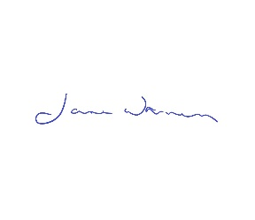
Dated 19/05/2020

